Yuan Ze University 2023 TEEP@YZU Innovation Design Engineering Internship Program
Project title | Cold Storage Temperature Management
Department | Department of Computer Science & Engineering
Advisor | Quang-Thai HoPh.D
Duration | 01/07 – 21/09/2023
Final result | For the purpose of monitoring the temperature of the cold storage space, temperature sensors are used to monitor storage temperatures. Temperature sensors, however, can only measure the temperature of the storage space in which they are located. As a result, locations without sensors will not know the precise temperature and may affect the quality of goods if the temperature increases. In this study, we use the Trilinear Interpolation method to calculate the temperature of all locations of the cold storage, including locations without sensors, based on the values of existing sensors. Besides, we designed the Space Dividing method that supports changing the number of sensors in the storage to increase the accuracy of Trilinear Interpolation. Based on those methods, the Cold Storage Temperature Management web application is built on the Python Django Rest Framework for Web services and Angular for the interface. This web application also supports authenticating users and managing pallet locations in storage.
Information of students | We are software engineering graduates from Can Tho University in Vietnam. We focus on the processes of developing and building software. After graduating, we became teaching assistants at the Faculty of Software Engineering, at Can Tho University. Then, we were awarded this program by Dr. Quang-Thai Ho, and we were honored to receive acceptance from Yuan Ze University in Taiwan. We would like to express our gratitude to YZU for giving us the chance to experience a wonderful learning environment at YZU and a beautiful country like Taiwan.
- Minh Bang Le | I am a student at the Faculty of Software Engineering, College of Information and Technology, Can Tho University in Vietnam. During my internship at Yuan Ze University, I developed my project that is building a web service for cold storage management. In this project, I developed a set of services to support the business process in cold storage, such as organization management, pallet location management, temperature management, etc. The most special feature is temperature management, which helps people supervise the temperature changes at every location without sensors in cold storage. For this feature, I applied the trilinear interpolation technique, and my own technique that is space dividing.  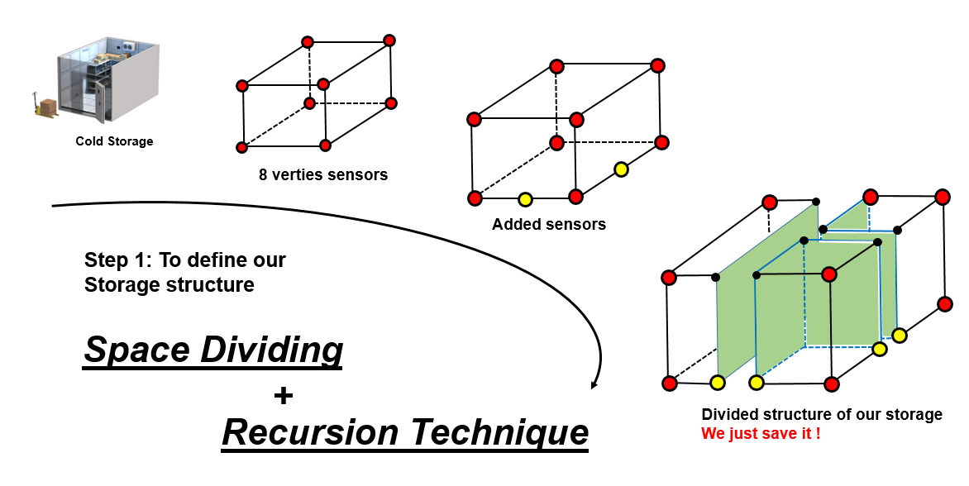  Figure 1: In the first step, we used space dividing and recursion techniques  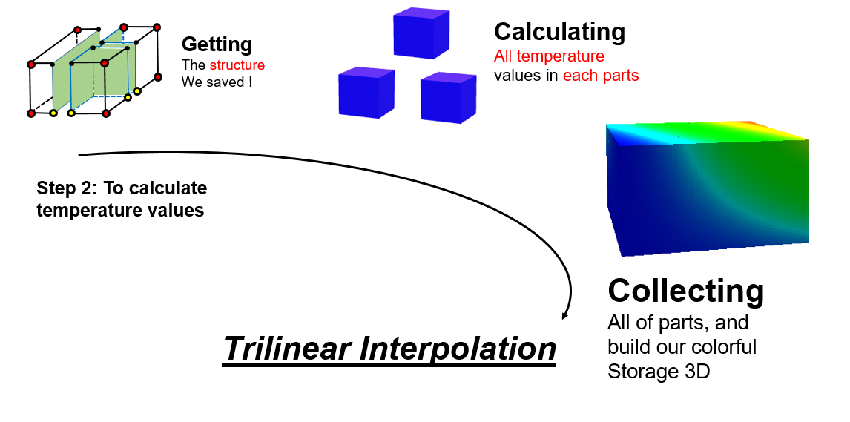  Figure 2: In the second step, we calculated all temperatures by trilinear interpolation  In addition, I also developed its database.  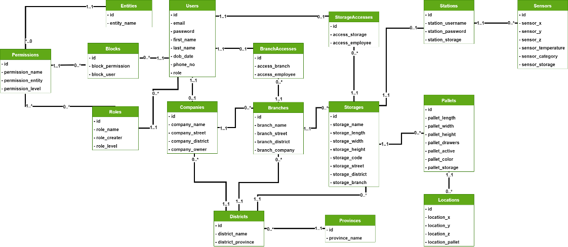  Figure 3: The database design of this web application
- Cong Danh Cao | I come from the Department of Software Engineering, Can Tho University, Viet Nam. My partner and I have done a project about building cold storage management web application, my work is to build a subsystem which simulates temperature and several objects in cold storage in 3D space. Because the temperature in storage is not uniform in different areas, by much research, I have simulated temperature at each point in storage as 3D space by matching temperature value with color, and represent them on the interface. Moreover, I have simulated some 3D objects, such as: storage, shelves and arrange shelves, sensor network,…Besides simulation, some business processes have been developed, for instance: account management, organizational structure for company,…Finally, I hope this proposal could bring some values into related fields.  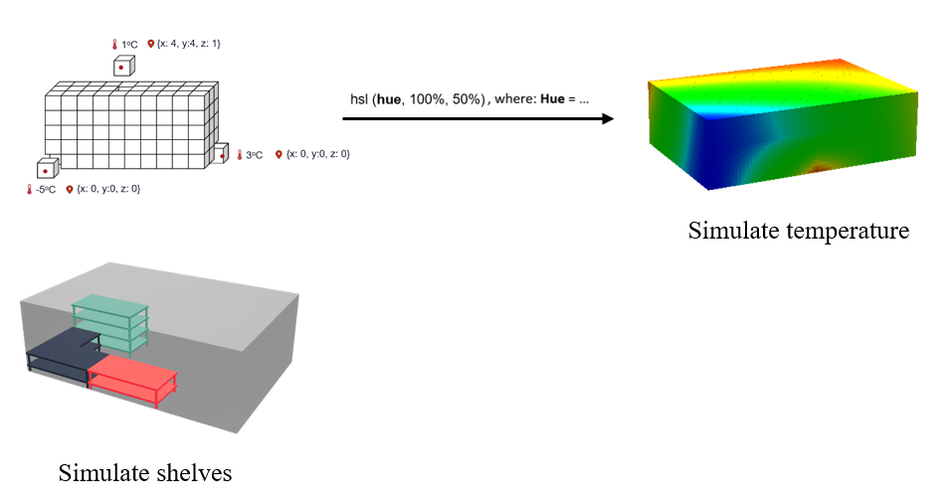  Figure 4: Visualizingtemperatures and pallect locations onto user interface

